USER GUIDE

DOWNLOAD DATA

September 2018

Version 1.01

Pharmacon ITC303/309 Group

Document Revisions

|  |  |  |
| --- | --- | --- |
| Date | Version Number | Document Changes |
| 10/09/2018 | 1.01 | Initial |
|  |  |  |
|  |  |  |
|  |  |  |
|  |  |  |
|  |  |  |
|  |  |  |
|  |  |  |
|  |  |  |

Table of Contents

1 Introduction 4

1.1 Scope and Purpose 4

1.2 Process Overview 4

2 Download Data 5

2.1 Login – Administration User 5

2.1.1 To Log in to Pharmacy Error Tracker (PET) 5

2.2 Reports – Download Data 6

2.2.1 Navigate to Download Data 6

2.2.2 Download Data Details 7

# Introduction

## Scope and Purpose

The purpose of this user guide is to provide instructions on how to download data from PET into a .csv file. No other features of the Pharmacy Error Tracker (PET) application will be discussed in this user guide.

* To be able to use PET, the user will need basic knowledge of logging into an online application and using a manage function to locate records.
* Basic knowledge of being able to download and save a file to a local PC is required.
* This feature is only available to a user with administrator rights.

## Process Overview

The administrator will need to log into PET using their valid username and password.

* The Welcome Page will be presented on successful login.
* The administrator will need to be able to navigate to the Reporting function of PET.

# Download Data

PET has the ability to download a .csv file containing data relating to errors that have been logged within a set of dates entered by the user.

## Login – Administration User

User must have access to the application.

User must have a valid username and password with administration rights.

### To Log in to Pharmacy Error Tracker (PET)

1. Launch the application.
2. Click in the Username field.
3. Enter username.
4. Tab or click in Password field.
5. Enter password.

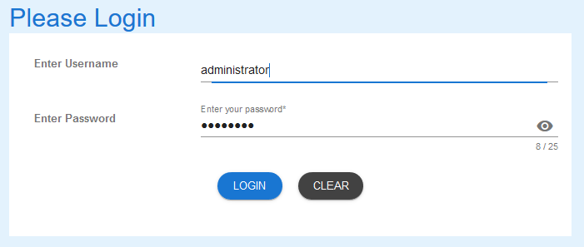

1. Select LOGIN to access PET.

NOTE:

Users entering an invalid username and/or password will not beable to access PET.

## Reports – Download Data

User is required to navigate the Download Data button either via the menu bar or the Welcome Page.

### Navigate to Download Data

1. From the Welcome Page, there are two ways to navigate to “Download Data”:
   1. Select the “Download Data” from the list



* 1. From the Menu Bar, hover your mouse over “Reporting…” and select “Download Data”



1. The Download Data form will appear.

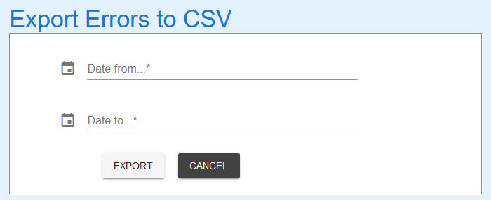

### Download Data Details

1. Enter the date range for which data is required.

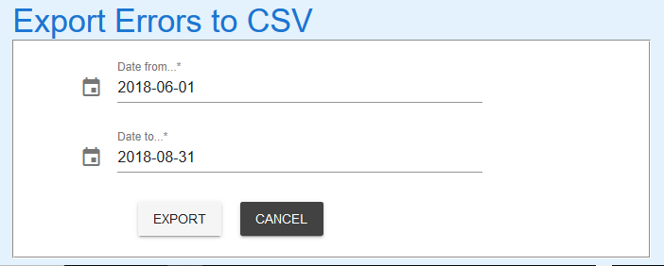

1. Select the EXPORT button and success message appears.

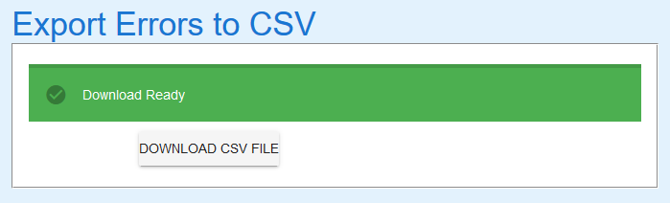

1. Select the DOWNLOAD CSV FILE button download file to the local PC. The following pop-up will appear. Select appropriate option to suit needs.

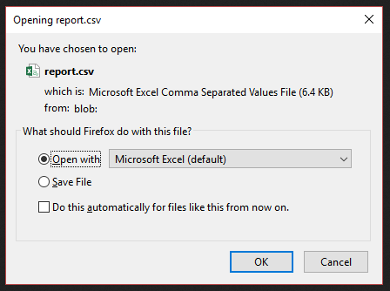

1. File opened in Excel will show details such as below.

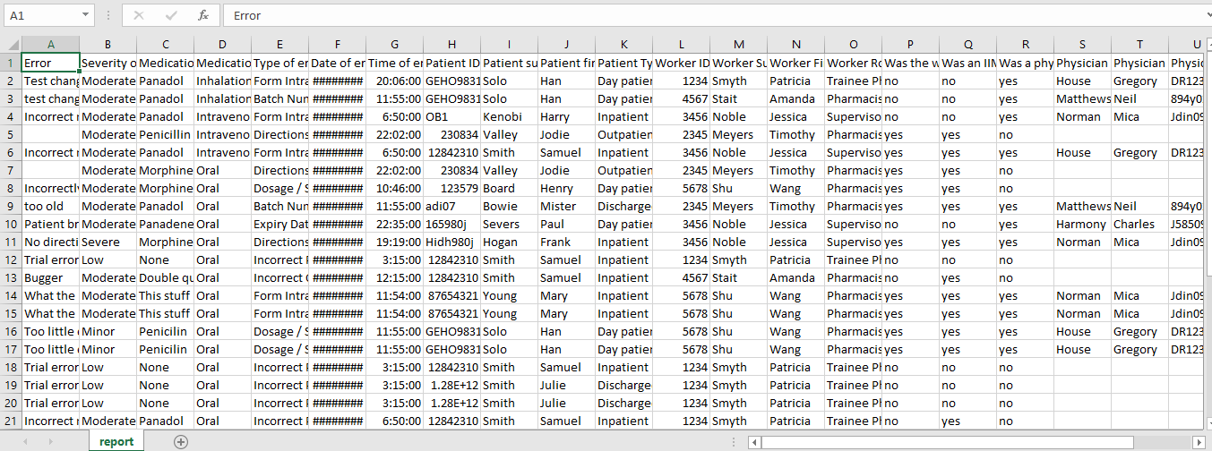

File can be saved from Excel as per usual procedure (File > Save As)

1. If “Save File” option is selected, navigate to the desired location on your machine to save the report.csv file.

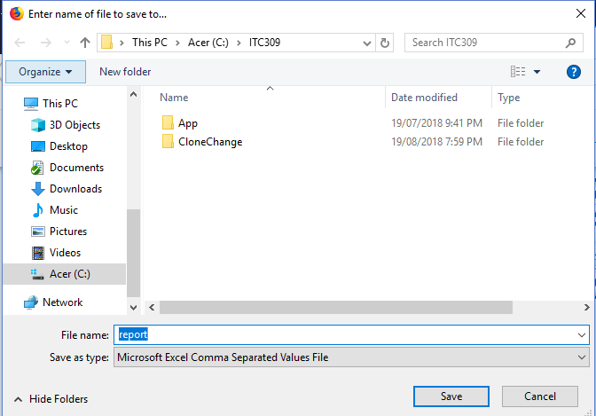

If you encounter issues not addressed by this user guide, please contact your account manager for additional support.